**Project 3**

**Step1: Create two linux instances,Use the first free Linux AMI.**

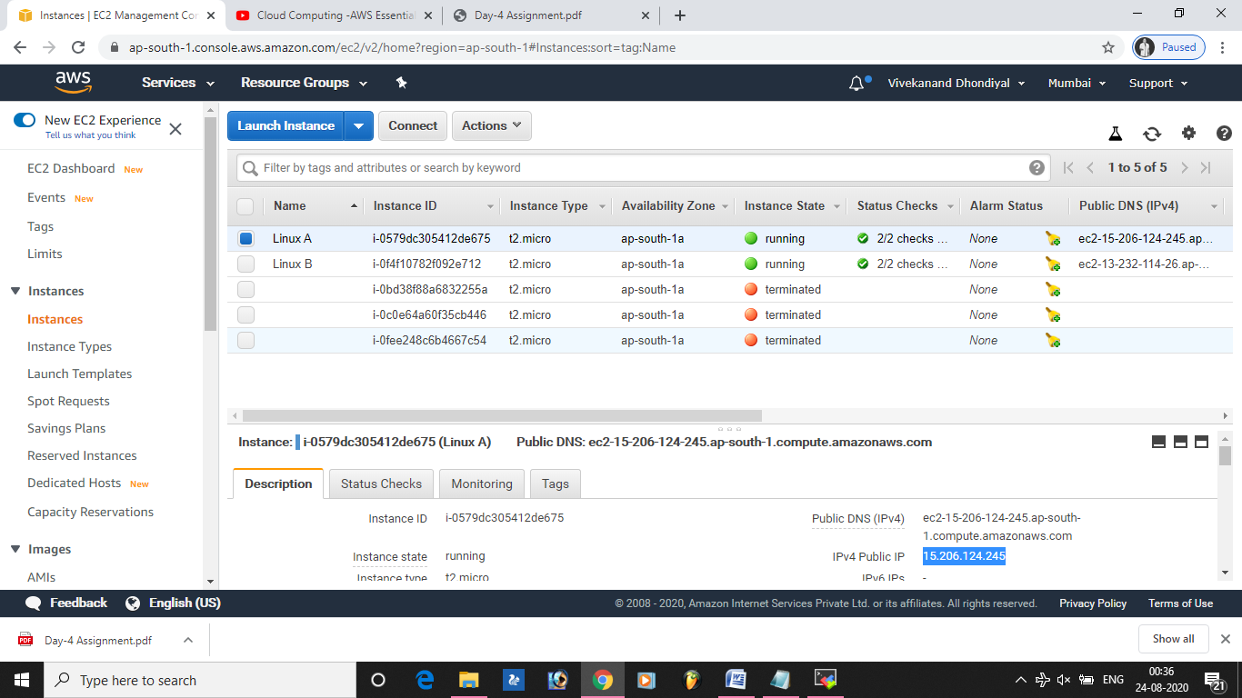

**Step2: Launch both instances using Mobaxterm**

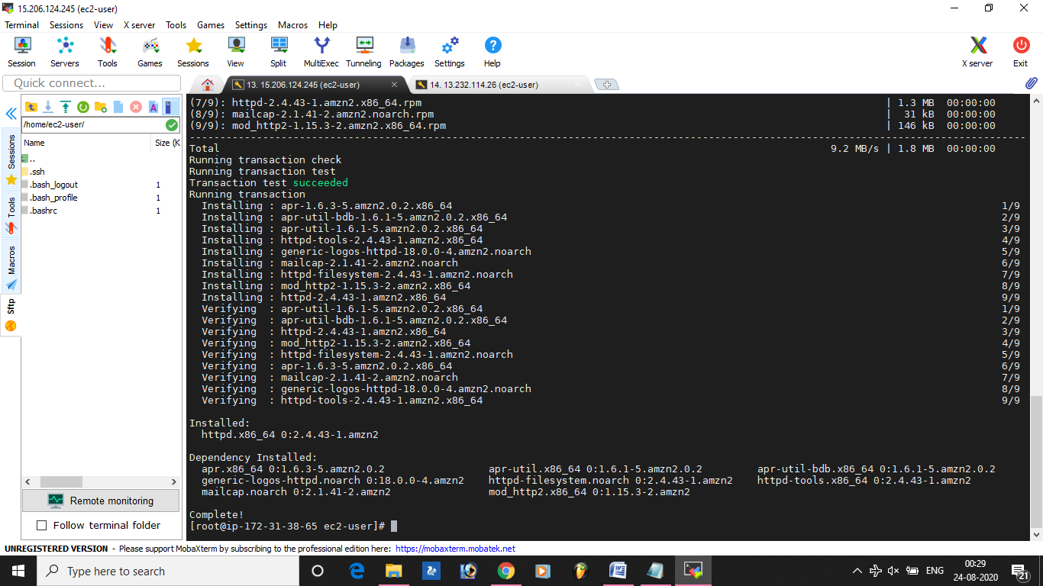

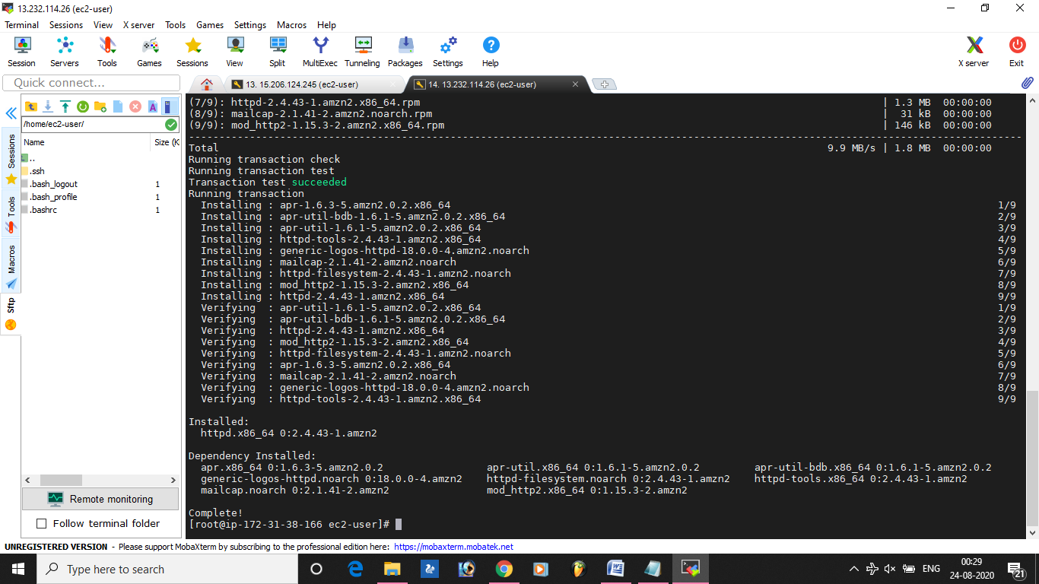

Step3 :Host html login webpage on both servers

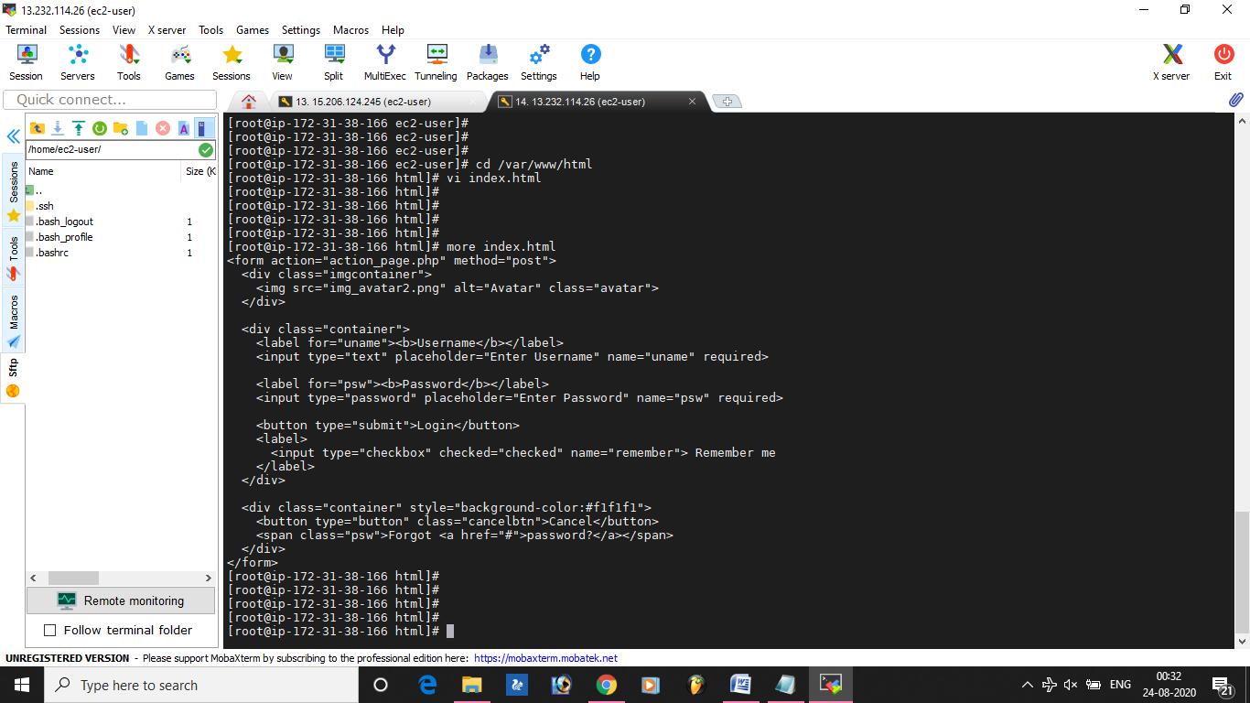

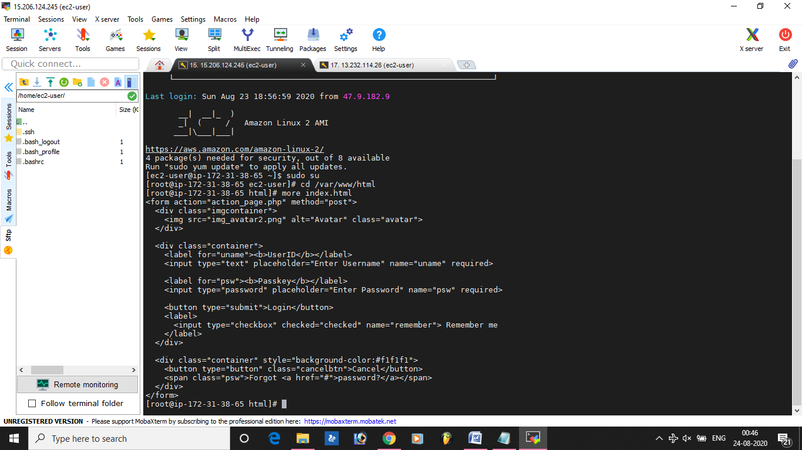

**Step4 : Check if the application is deployed on both servers by copy pasting the public ip of the servers into the browser**

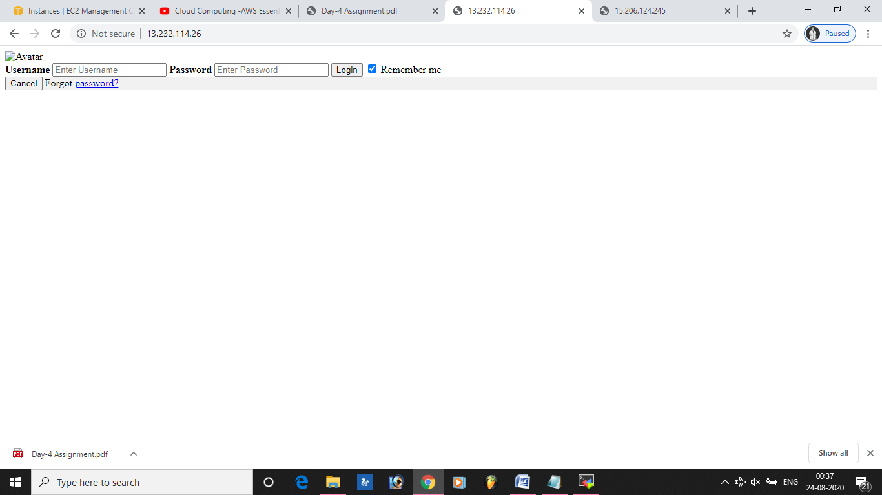

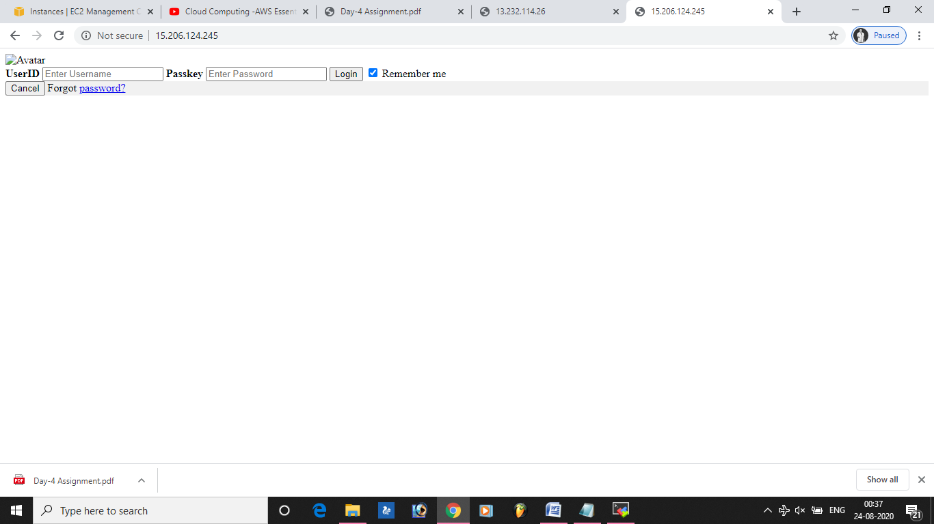

**Step5 : Create a application Load balancer with the above two instances as targets**

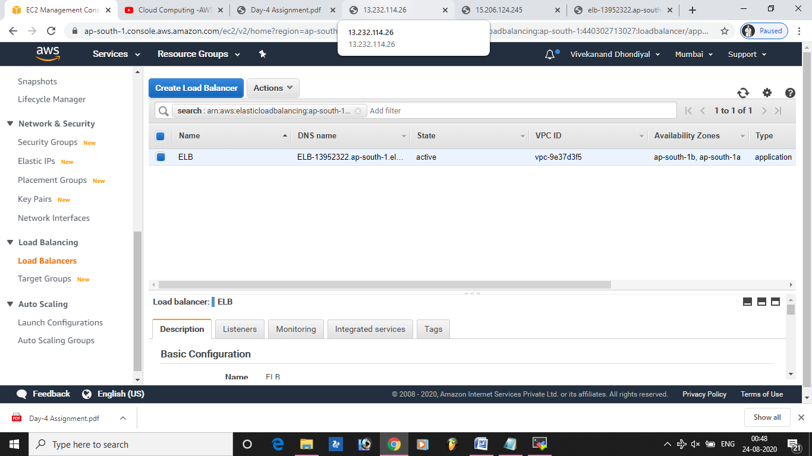

**Step7:Check the functioning of ELB**

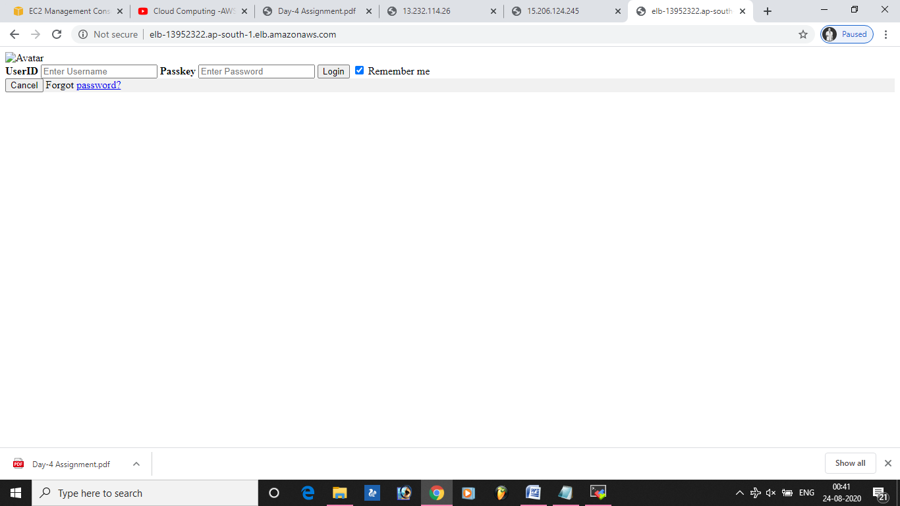

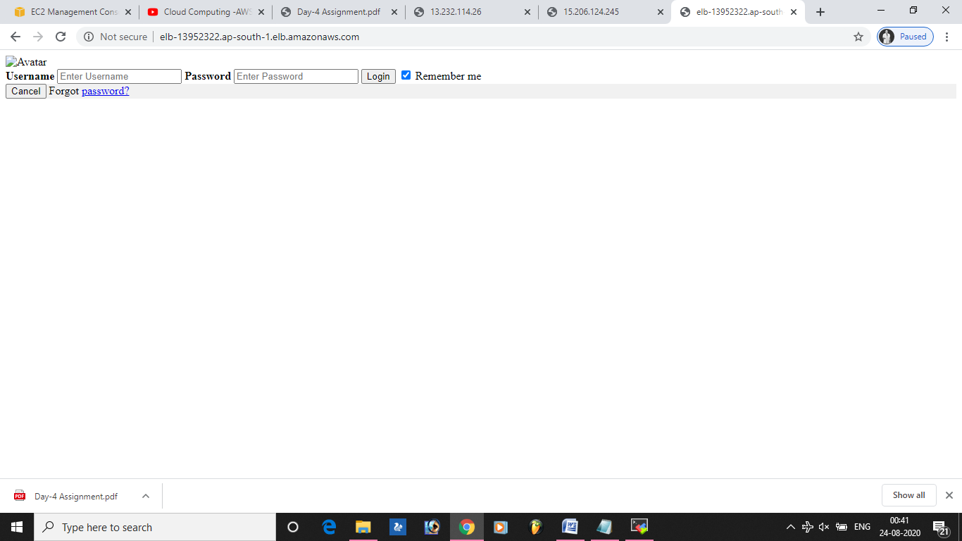

**Thankyou LetsUpgrade & Vinolin Mam.**